19.31: 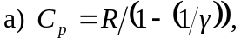and so
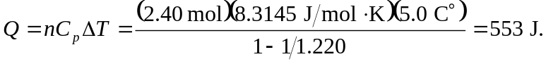

(An extra figure was kept for these calculations.)

